Commercial Activity Tax

Ohio’s way to receive corporate state income tax.

If annual gross sales are greater than $1M, CAT tax needs filed quarterly (Typically 1st week of February, May, August, November).

If gross sales are less than $1M, CAT tax needs filed annually (by 1st week of May).

Locate your client’s login information through the “Client Info USE 02-03-22” excel file. Open a browser and navigate to the OBG website (https://ohid.ohio.gov/wps/portal/gov/ohid). Login with your client credentials. Click Open App, as seen below.

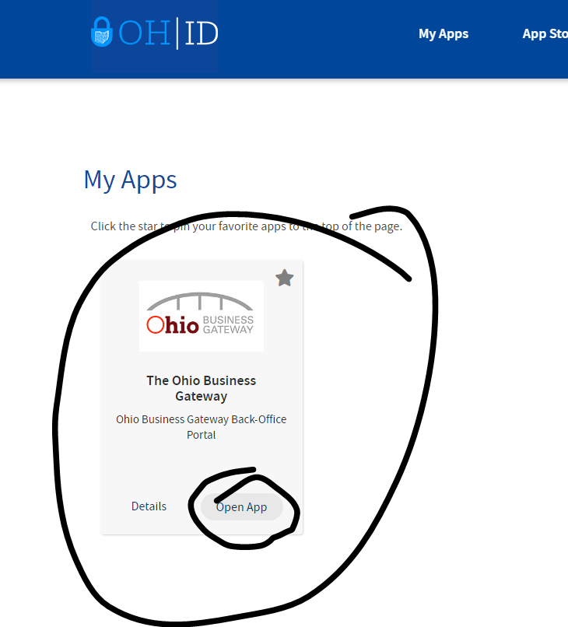

Click the CAT Annual or Quarterly button to start the process

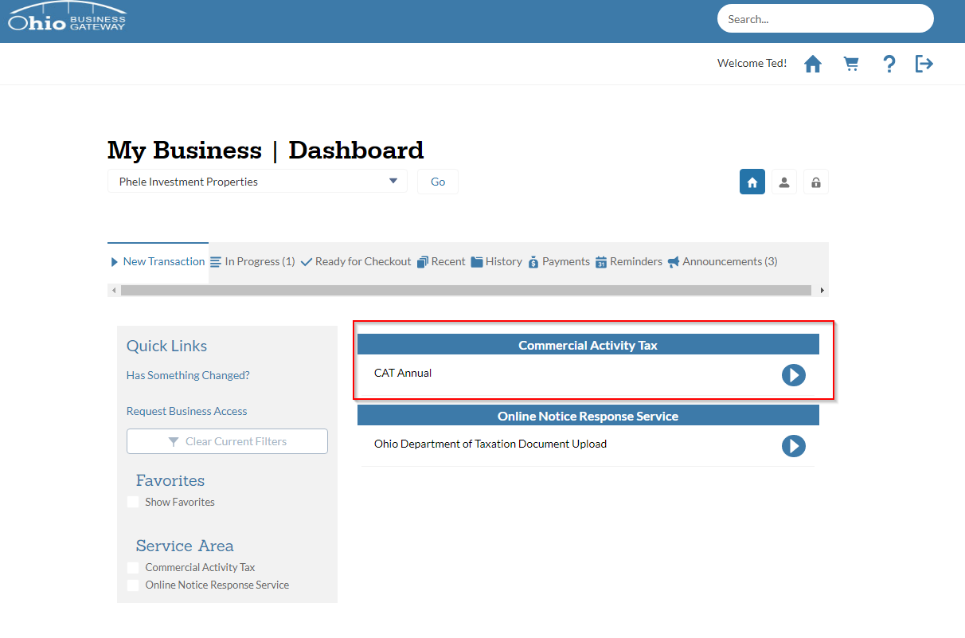

Tick the Acknowledgement box and choose “Next.” Fill in the applicable fields on the next page. Payments will be a period in arrears. I.e. by 05/10/22, we will be paying CAT tax for the 2021 reporting period.

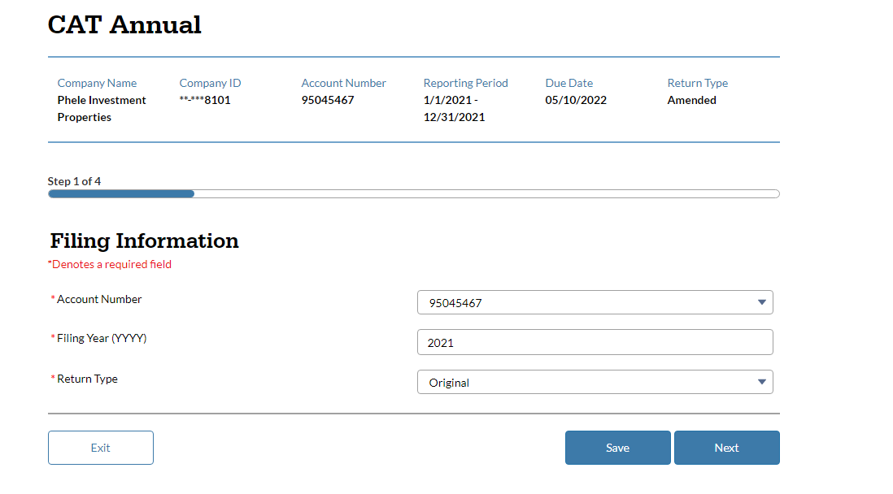

Next, you will need to understand the business’s gross receipts for the time period. All gross sales used for CAT tax should be cash basis.

If it is an annual CAT client, we can pull this from the tax return (if completed) or our bookkeeping financials. See screenshot below. Although Phele is unique since it is rental income (realized on form 8825), typically gross sales will be on page 1, line 1.

If it is a quarterly CAT client, gross receipts should be pulled and documented from QuickBooks. If they are not a bookkeeping client of ours, reach out to the client and have them provide a quarterly P&L from their quickbooks.
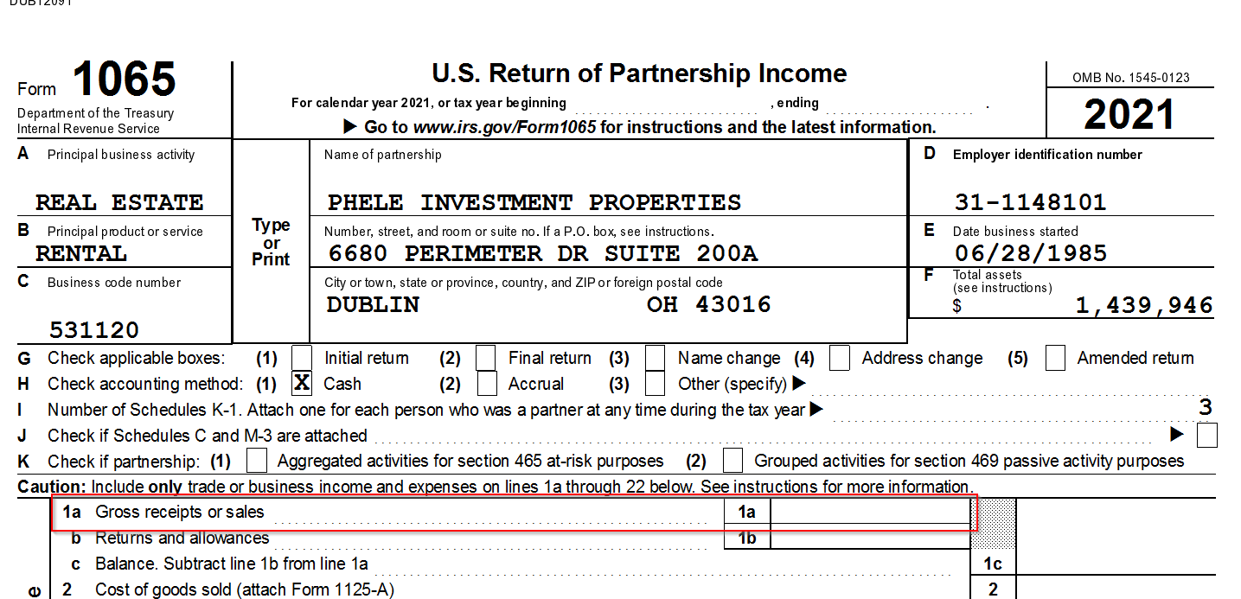

Type in the business’s gross receipts from the prior period. Typically will be located on Page 1 of the tax return but can be found on our bookkeeping P&L.

See screenshot 2 for Phele’s gross receipts since they are a rental property business.

Click next and review the summary page. If all information is correct, type in your email address, tick the checkbox, and click file. Take a screenshot of the confirmation page and save it to FileCabinet. In addition, email the client the screenshot and inform them of the amount paid.

